**Scale and Rotation Invariant Image Search**

**Framework**

Ajeet Goyal (B14CS003) Ajeet Ujjwal (B14CS004)

Mentor: Dr. Chiranjoy Chattopadhyay

**Abstract**

In this paper, we propose two different schemes towards the recognition of multi-oriented and multi-sized floorplan-images. In the first approach distances of centroids of all connected components are taken from the global centroid. These distances are arranged in a particular order along with angles which works as a scale and rotation invariant feature. In the second approach we arrange the centroids of all connected components in circular zones and apply clustering then we calculate the angles of these clustered points and global centroids of each zone in a specific format such that these angles work as rotation and scale invariant features.

**Objective**

1. Given a rotated or scaled floorplan image recognize it as the original image without correction.
2. To propose novel approaches to find scale and rotation invariant features in images.
3. To implement the proposed techniques and compare the performances.

**Motivation**

A lot of work has been done to recognize characters of different orientations and scale. The approaches proposed previously works mainly on characters or simple images. But when applied to images with lot of components like floorplan images these techniques does not work properly. So there is a need to propose solutions to recognize differently oriented and scaled multicomponent images.

**Research Issues and Challenges**

In many cases orientation of components may be same but those components may be completely different with each other. Therefore two completely different images may be recognized similar because their orientations are matching.

Also floor-plan images are very large and their rotation causes a lot of distortion in the image. It is necessary to minimize the effect of noise and distortion of images using morphological operations. Also algorithm need to find similar images given to input image which may have different number of components also. As the difference in number of connected components between the input image and original image increases, it becomes difficult to recognize the image correctly (it may match with a different image having same number of connected components).

**Methodology**

First step is to binarize the floorplan image and remove the boundary (wall, door, and window). Then we apply preprocessing operations and only after that we apply the proposed approaches.

**Preprocessing the image:**

* ApplyClosing operation on the image with disc as a structuring element.
* Apply Filling operation to fill the holes in all connected components of the image.
* Now remove all the connected components which have number less than a specific threshold value.

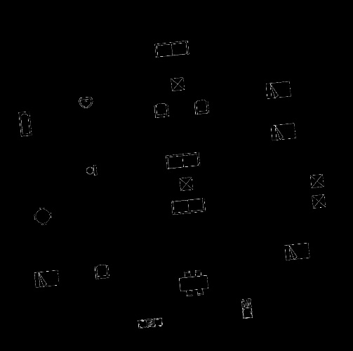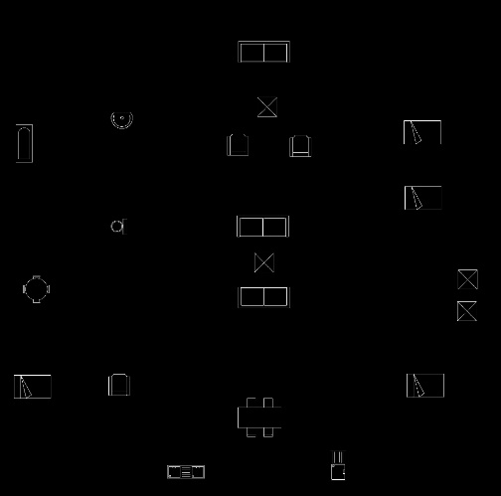

Fig 1(b): Rotated Image - 142 connected components

Fig 1(a): Original Image - 50 connected components

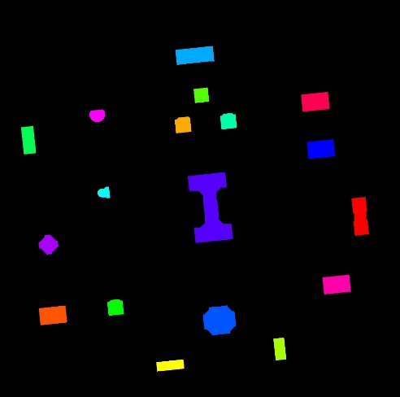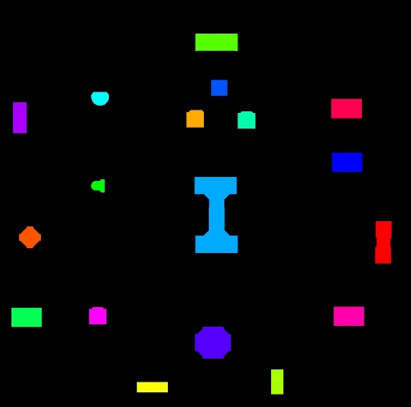

Fig 1(c): Preprocessed Original Image - 18 connected components

Fig 1(d): Preprocessed Rotated Image - 18 connected components

Before preprocessing the number of connected components changes drastically from original to rotated image (figure 1(a) and figure 1(b)). After preprocessing the number of connected components becomes equal (figure 1(c) and 1(d)) in the rotated and original images.

**Images with corresponding no of connected components (CC) before and after preprocessing:**

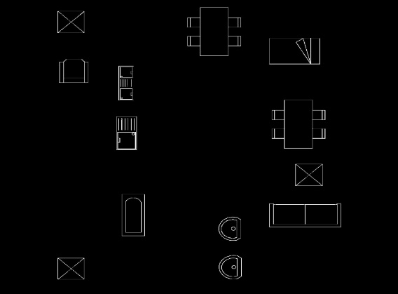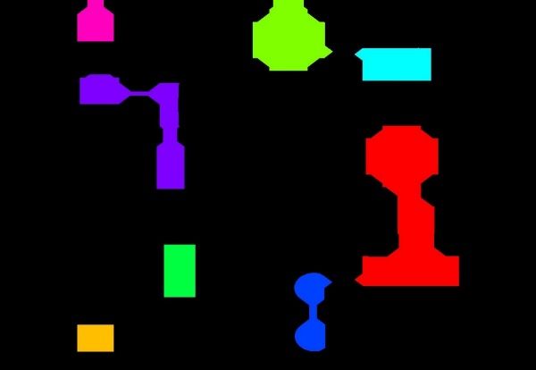

CC: 8

CC: 36

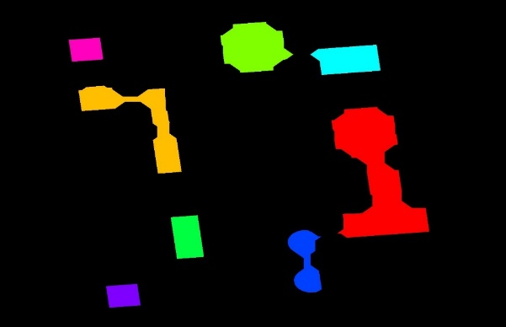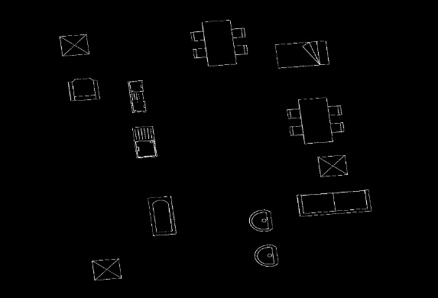

CC: 8

CC: 88

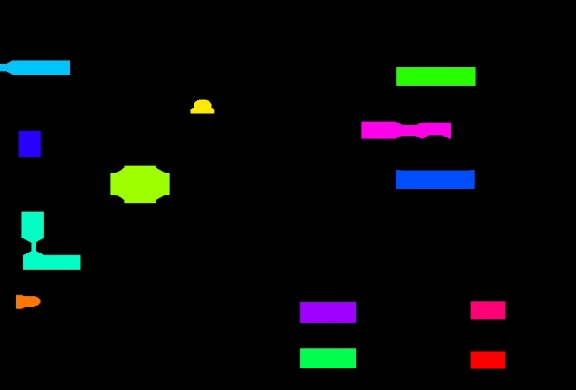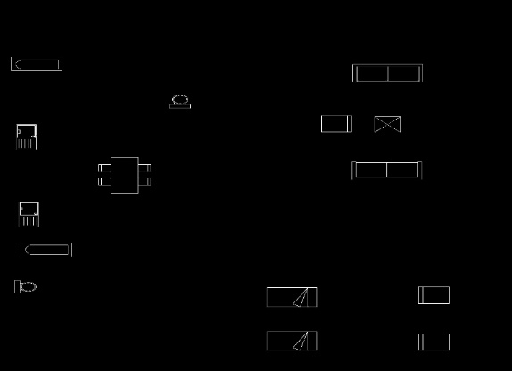

CC: 13

CC: 36

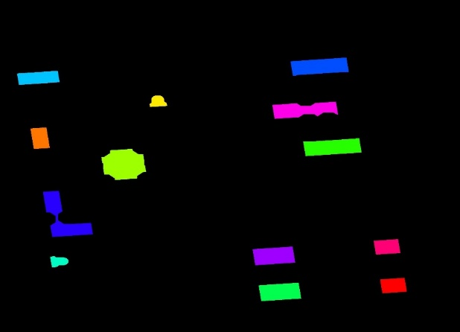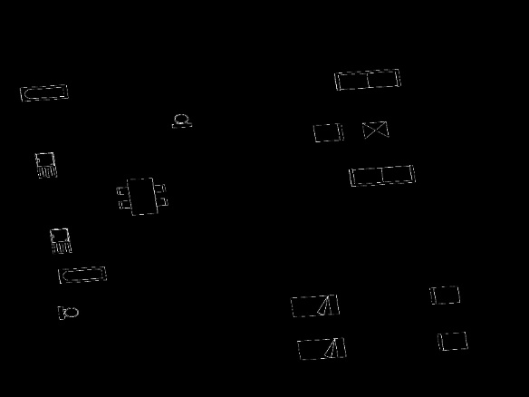

CC: 13

CC: 90

After preprocessing number of connected components are shown correctly so now we are able to apply our rotation and scale invariant approaches on the resultant images.

**Approach 1:**

* Find centroids of all connected components and centroid of the image (global centroid).
* Chose any centroid point which has largest distance from the global centroid.
* Calculate angles of all the lines joining centroids of connected components from line joining global centroid and the chosen point in clockwise order. Also find distances of those lines in the same order.
* Now feature vector contains these distances and their corresponding angles.

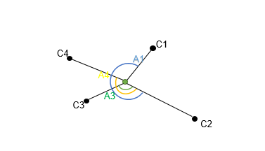

**Figure 2**

In Figure 2 C1, C2, C3 and C4 represents the centroids of connected components with C2 having the largest distance from center (global centroid). ND1, ND2, ND3, ND4 are normalized distances w.r.t D1, D2, D3 and D4 respectively. Then the feature vector according to Approach 1 is:

**<ND2 ND3 ND4 ND1 0 A3 A4 A1>**

**Approach 2:**

* Find centroids of all connected components and centroid of the image (global centroid).
* Divide the image in concentric circular zones.
* For each zone apply clustering to compute two centroid points and global centroid of zone
* Now we have 3 set of points - 2 from clustering and 1 global centroid for all zones
* Now angles are computed among different centroids within a set.
* Angles are computed from a point from exterior zone to all different combination of inner zone points considering each inner points as vertex of the angle.

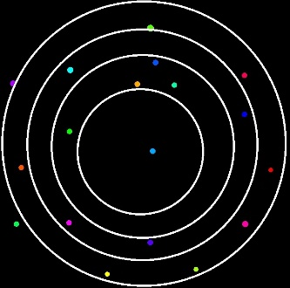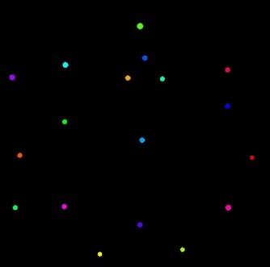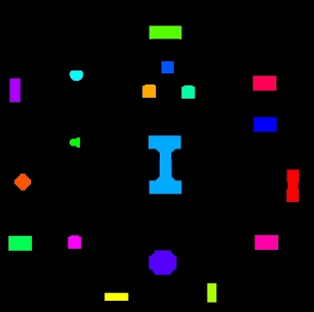

(c)

(b)

(a)

**Fig 2:** (a) Preprocessed image (b) Centroids of connected components (c) Division in concentric circular zones

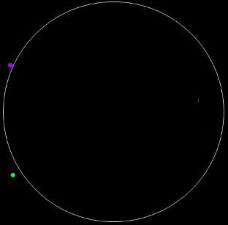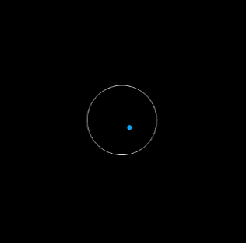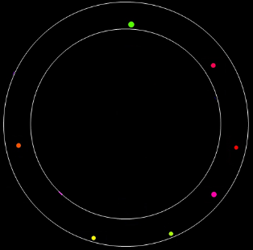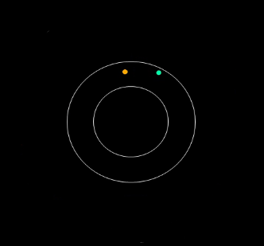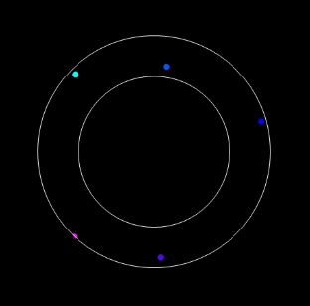

**Fig 3:** Five different zones created by concentric division

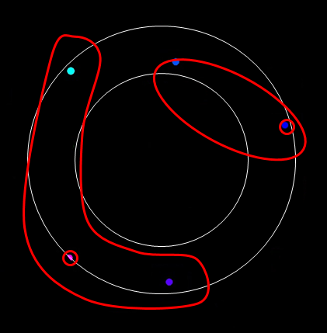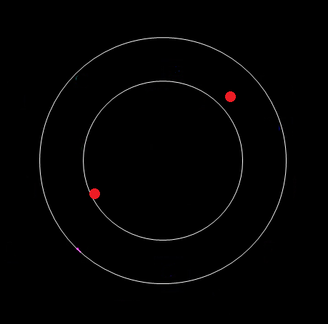

**Fig 4:** Clustering of points in Zone 4 give two cluster points

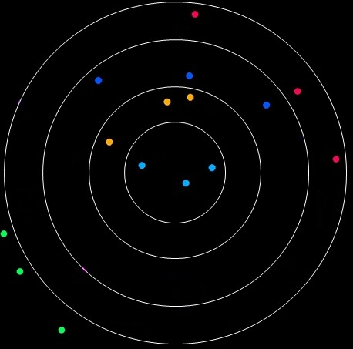

**Fig 5:** Three sets of points are formed. Set1 contain one Global Centroid from each zone. Set2 contains one Cluster point of each zone which is closer to the global centroid of that zone. Set3 contains one Cluster point of each zone which is farther to the global centroid of that zone.

**Comparison of feature vector:**

* **Case 1:** If both vectors have same length.

*function* PercentMatch:

*input*: vector1, vector2 & threshold

*output*: Percentage similarity

n = length(vector1);

matched = 0;

*for* i = 1 *to* n

*if* abs(vector1[i] - vector2[i]) <= threshold *then*

matched++;

*return* matched * 100 / n;

**Example:**

*threshold* = 0.1

*vector1* = [ **1** 2 **3** **4 5**]

*vector2* = [**1.1** 2.3 **3** **3.9 5.1**]

*PercentMatch* = 4 * 100 / 5 = 80 %

* **Case 2**: If both vectors have different length.

*function* PercentMatch:

*input*: vector1, vector2 & threshold (let vector1 be the smaller one)

*output*: Percentage similarity

s = length(vector1);

b = length(vector2);

matched = 0;

bs = 1; // starting index of vector2

*for* i = 1 *to* s

*for* j = bs *to* b

*if* abs(vector1[ i ] - vector2[ j ]) <= threshold *then*

matched++;

bs = j + 1;

break;

*return* matched * 100 / b;

**Example:**

*threshold* = 0.1

*vector1* = [ **1** 2 **3** **4** **5**]

*vector2* = [**1.1** 2.3 **3** 4.5 **3.9** **5.1**]

*PercentMatch* = 4 * 100 / 6 = 66.67 %

**Results and Findings**

We had 15 floorplan images initially. We added 1 and 2 extra components to all these images to get two more sets of floorplan images containing 15 images each. Now the Images in first, second and third set has 0, 1 and 2 extra components respectively. 240 input images were taken for each set with different orientations and scales with respect to the images in the given set are taken to check the accuracy.

As the difference in number of connected components increases between input image and original image the approach based on circular division (Approach 2) fails miserably as even a single extra connected component causes a lot of effect on the feature vector.

|  |  |  |
| --- | --- | --- |
| **No of Extra Components** | **Approach 1 (% accuracy)** | **Approach 2 (% accuracy)** |
| 0 | 98.33 | 97.50 |
| 1 | 94.58 | 47.08 |
| 2 | 79.16 | 42.91 |

**Future Work**

Till now we have proposed the techniques to check if the configuration of centroids of all the connected components with respect to the global centroid of an image are similar to other images or not, without getting into the details whether their respective connected components are actually similar or not. We have centroid of the connected components of the images as the only property to check similarity between the given images. Future work involves finding whether the individual connected components are actually similar or not by checking properties other than centroids such as size, shape etc. of the connected components. We will need to keep track of a vector of properties on each node to make sure that individual connected components are also similar along with the configuration of the complete image.

**Conclusion**

We have proposed two novel approaches to recognize multi-oriented and multi-sized floorplan images. Both approaches use centroids of connected components to find the scale and rotation invariant features of the images. First approach uses distances of centroids of connected components from global centroid and use these distances along with angle information to get rotation and scale invariant feature. Second approach arranges the centroids of connected components in circular zones followed by clustering to get 2 cluster points in each zone. Now we compute the angular information of these cluster points in a specific format to get scale and rotation invariant features. Both the approaches work great when number of connected components are same in the input image and original image. But when number of connected components are different then Approach 1 works considerably well than Approach 2.

The work done so far has limitation that it recognizes two different images as same if both images have same orientation of components. Other properties of connected components such as shape and size need to be examined to check if the images are actually similar or not.

**References**

1. M. Nasipuri N. Tripathi, T. Chakraborti and U. Pal. a. *In Proceedings of 23rd International Conference on Pattern Recognition* on A scale and rotation invariant scheme for multi-oriented character recognition, pages 4041-4046, 2016.
2. U. Pal and N. Tripathy. A contour distance-based approach for multi-oriented and multi-sized character recognition. *Sadhana*, 34(5):755-765, 2009.